**SQOOP PRACTICE**

**MYSQL Commands:**

mysql –u root –p

Root

mysql> show databases;

mysql> create Database_name;

mysql> show databases;

mysql> use Database_name;

mysql> create table something(num int primary key, name varchar(50), number int);

mysql> insert into something values(123, ‘abc’, 234);

.

.

.

mysql> select * from something;

mysql> grant all privileges on Database_name.* to ‘%’@’localhost’;

mysql> grant all privileges on Database_name.* to ‘’@’localhost’;

**SQOOP Commands:**

sqoop import --connect jdbc:mysql://localhost/Batch50 --table empl;

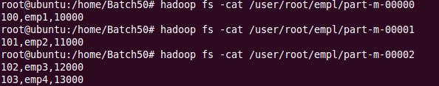

sqoop import --connect jdbc:mysql://localhost/Batch50 --table empl –m 1 –target-dir /Import50;

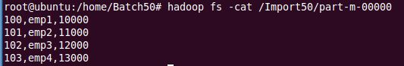

sqoop import --connect jdbc:mysql://localhost/Batch50 --table empl –m 1 –target-dir /Field50 --fields-terminated-by ‘\t’;

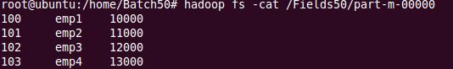

sqoop import --connect jdbc:mysql://localhost/Batch50 --table empl –m 1 –target-dir /Condition50 --fields-terminated-by ‘\t’ --where ‘amt>11000’;

C:\Users\Guest\Pictures\4.JPG

sqoop import --connect jdbc:mysql://localhost/Batch50 --table empl –m 1 –target-dir /Condition50 --fields-terminated-by ‘|’ --columns 'id, name’;

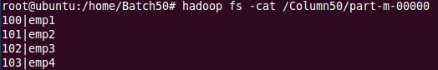

sqoop list-databases --connect jdbc:mysql://localhost;

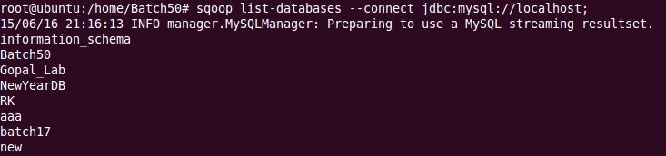

sqoop list-tables --connect jdbc:mysql://localhost/Gopal_Lab;

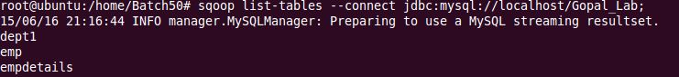

sqoop import --connect jdbc:mysql://localhost/Batch50 --table empl –m 1 –target-dir /SEQFile50;

C:\Users\Guest\Pictures\8.JPG

sqoop import --connect jdbc:mysql://localhost/Batch50 --table empl –m 1 –target-dir /AVROFile50;

C:\Users\Guest\Pictures\9.JPG

Note: AVRO files are read as “.avro” file formats.

sqoop eval --connect jdbc:mysql://localhost/Batch50 --query “select * from empl”;

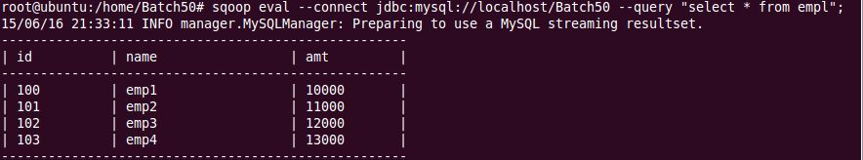

sqoop eval --connect jdbc:mysql://localhost/Batch50 --query “select * from empl limit 2”;

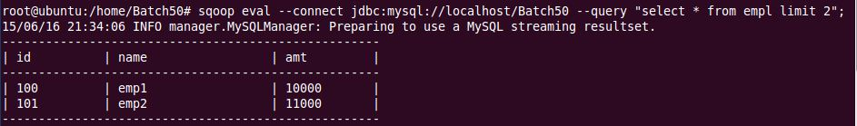

sqoop eval --connect jdbc:mysql://localhost/Batch50 --query “create table evaltab(evid int primary key, evname varchar(50), evsal int)”;

sqoop eval --connect jdbc:mysql://localhost/Batch50 --query “show tables”;

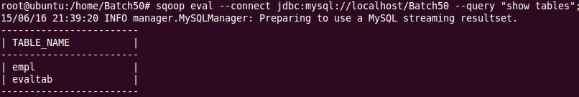

sqoop eval --connect jdbc:mysql://localhost/Batch50 --query “insert into evaltab values(10201, ‘EVName1’, 12345)”;

sqoop eval --connect jdbc:mysql://localhost/Batch50 --query “insert into evaltab values(10202, ‘EVName2’, 22345)”;

sqoop eval --connect jdbc:mysql://localhost/Batch50 --query “insert into evaltab values(10203, ‘EVName3’, 13345)”;

sqoop eval --connect jdbc:mysql://localhost/Batch50 --query “insert into evaltab values(10204, ‘EVName4’, 12445)”;

sqoop eval --connect jdbc:mysql://localhost/Batch50 --query “insert into evaltab values(10205, ‘EVName5’, 12355)”;

sqoop eval --connect jdbc:mysql://localhost/Batch50 --query “insert into evaltab values(10206, ‘EVName6’, 12346)”;

sqoop eval --connect jdbc:mysql://localhost/Batch50 --query “select * from evaltab”;

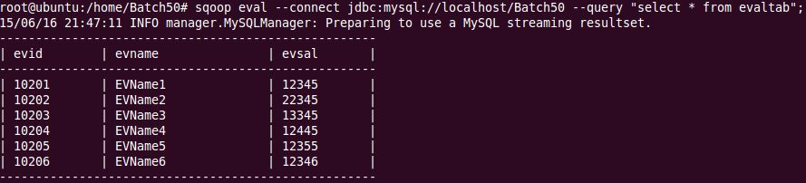

sqoop eval --connect jdbc:mysql://localhost/Batch50 --query “drop table evaltab”;

sqoop eval --connect jdbc:mysql://localhost/Batch50 --query “show tables”;

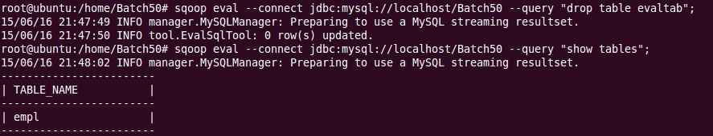

sqoop eval --connect jdbc:mysql://localhost/Batch50 --query “select COUNT(*) from empl”;

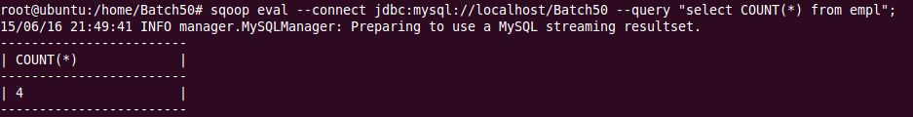

sqoop eval --connect jdbc:mysql://localhost/Batch50 --query “select DISTINCT(id) from empl”;

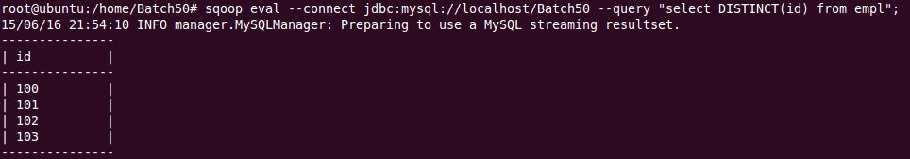

sqoop eval --connect jdbc:mysql://localhost/Batch50 --query “select * from empl”;

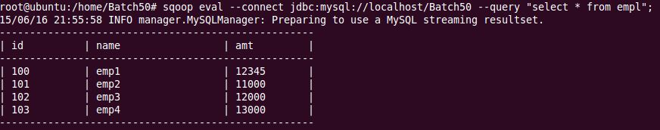

sqoop import --connect jdbc:mysql://localhost/Batch50 -m 1 --query “select * from empl WHERE \$CONDITIONS” --target-dir /Imports50;

sqoop import --connect jdbc:mysql://localhost/Batch50 -m 1 --query “select * from empl WHERE amt>11000 and \$CONDITIONS” --target-dir /Imports50;

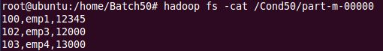

mysql> use Batch50;

mysql> show tables;

mysql> desc emp;

mysql> create table dept(deptid int primary key, dname varchar(50), dloc varchar(50), empid int, FOREIGN KEY (empid) REFERENCES emp(empid));

mysql> desc dept;

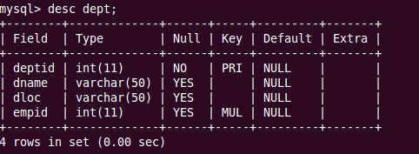

mysql> insert into dept values(200, ‘HRD’, ‘HYD’, 100);

.

.

.

mysql> select * from emp;

mysql> select * from dept;

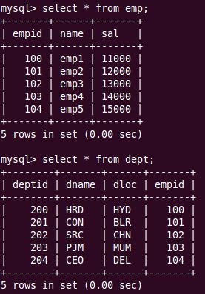

**Join:**

sqoop import --connect jdbc:mysql://localhost/Batch50 --query “select e.empid, name, sal, deptid, dname, dloc from emp e JOIN dept d ON (e.empid = d.empid) and \$CONDITIONS” --target-dir /NewJoin50 -m 1;

hadoop fs -cat /NewJoin50/part-m-00000

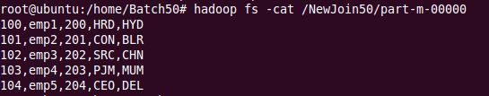

**Left Join:**

sqoop import --connect jdbc:mysql://localhost/Batch50 --query “select e.empid, name, sal, deptid, dname, dloc from emp e LEFT OUTER JOIN dept d ON (e.empid = d.empid) and \$CONDITIONS” --target-dir /LeftJoin50 -m 1;

hadoop fs -cat /LeftJoin50/part-m-00000

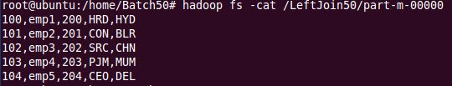

**Right Join:**

sqoop import --connect jdbc:mysql://localhost/Batch50 --query “select e.empid, name, sal, deptid, dname, dloc from emp e RIGHT OUTER JOIN dept d ON (e.empid = d.empid) and \$CONDITIONS” --target-dir /RightJoin50 -m 1;

hadoop fs -cat /RightJoin50/part-m-00000

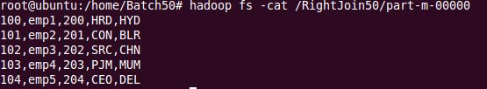

sqoop import --connect jdbc:mysql://localhost/Batch50 --table empl -m 1 --target-dir /Import50 –where ‘id > 102’ --append;

C:\Users\Guest\Pictures\24.JPG

mysql> create table exporttab(eid int primary key, ename varchar(50), eamt int);

mysql> desc exporttab;

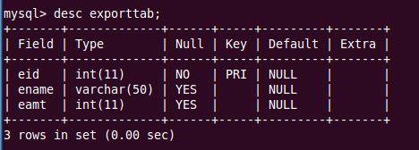

sqoop export --connect jdbc:mysql://localhost/Batch50 --table exporttab --export-dir /Import50/part-m-00000;

mysql> select * from exporttab;

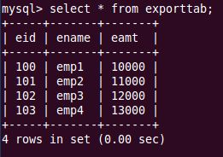

mysql> create table export(ids int primary key, names varchar(50), amts int);

nano Newfile.log

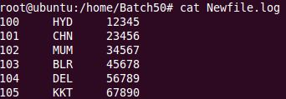

haoop fs -put Newfile.log /Import50

sqoop export --connect jdbc:mydql://localhost/Batch50 --table export --export-dir /Import50/Newfile.log --fields-terminated-by ‘\t’;

mysql> select * from export;

